THE CWEP™ BODY OF KNOWLEDGE
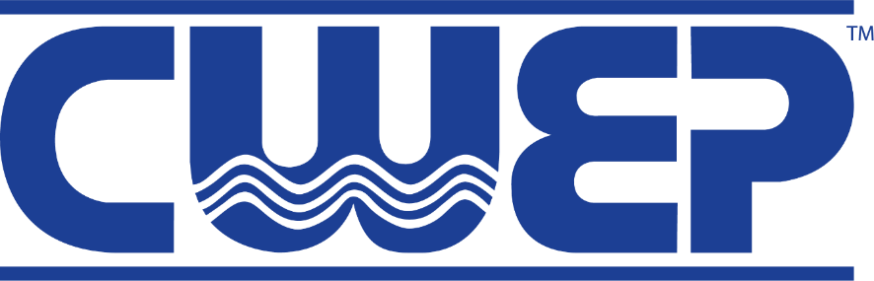

The CWEP Certification Exam is a four-hour open book exam. The examination questions are based on the Body of Knowledge listed below. Because of the diversity of background and experience of Water Efficiency Professionals, the examination has 16 different subject sections, all of which are included in the exam. You must bring a hand-held calculator to the exam as the CWEP exam does now allow computers, tablets, or cell phones to be used during the test.

The CWEP Examination contains the following mandatory subjects:
Body of Knowledge 2.0 | Percent of Exam
- Introduction to General Water Conservation | 2– 4%
- Policy, Standards, and Regulations | 2 – 4%
- Value of Water and Benchmarking | 4 – 6%
- Water Metering | 4 – 6%
- Water Balance & Audit Approach | 4 – 6%
- Measurement & Verification (M&V) | 3 – 5%
- Water Treatment | 6 – 10%
- Domestic Plumbing Fixtures | 8 – 12%
- Commercial Kitchen Equipment | 5 – 7%
- Laundry Equipment | 6 – 8%
- Cooling Towers and Steam Boilers | 8 – 12%
- Pools and Other Open Water Bodies | 5 – 7%
- Irrigation | 7 – 11%
- Additional ICI (Institutional, Commercial, and Industrial) Water Uses | 5 – 7%
- Medical, Research, and Lab Equipment | 6 – 8%
- Storm Water Management and Alternative Water Sources | 5 – 7%

